SPSS Commuter License Instructions
- Open IBM SPSS Statistics Commuter License from the start menu
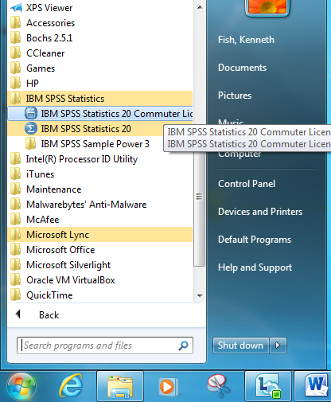
- Select the version you want to check out and set the Duration to the time you need it.
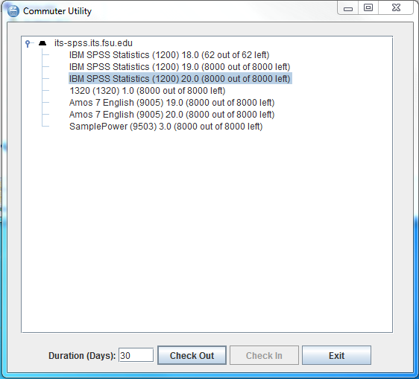
- Click “Check Out”
Changing Maximum Duration for Commuter License
Instructions for Windows
Note: You must be an Administrator to make these changes.
- Open Windows Explorer and navigate to your SPSS installation directory. (Default: C:\Program Files\IBM\SPSS\Statistics\20\)
- Copy spssprod.inf to the desktop
- Open spssprod.inf with Notepad
- Edit the line starting with CommuterMaxLife=7 to CommuterMaxLife=30
- Save spssprod.inf to the desktop
- Rename spssprod.inf in the SPSS installation folder to spssprodold.inf
- Move the spssprod.inf from the desktop to the SPSS installation folder
Instructions for Mac
- Open Finder and click on the Applications folder.
- Navigate to IBM/SPSS/Statistics/<version>/
- Single click on SPSSStatistics
- Click the gear icon and select Show Package Contents
- Then navigate to Contents/bin/
- Single click on spssprod.inf
- Click the gear icon and select Open With then choose Text Edit (you may have to select Other… first)
- Change the CommuterMaxLife= line to 30
- Click File then Save.

