SPSS 22 Setup Instructions
ITS – Software Licensing has changed the way we buy SPSS. With that have come many enhancements and a few changes to how we license SPSS. Each machine that uses SPSS will now need to be pointed to our SPSS Sentinel Server for authentication. Below are the steps that need to be taken to make sure your SPSS installations continue to work.
New Installations
- Open the appropriate file on the media and let the program extract the msi.
- Click “Next” on the Licensed Materials screen.
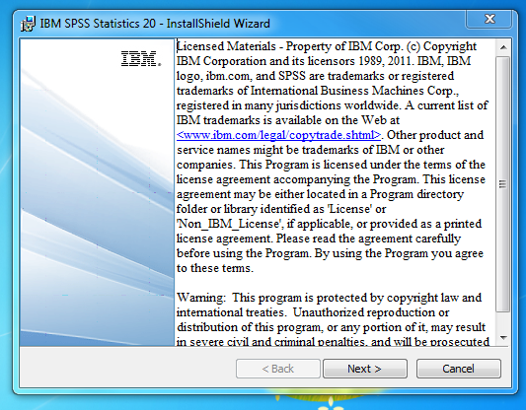
- Choose the “Concurrent user license” option and click “Next”.
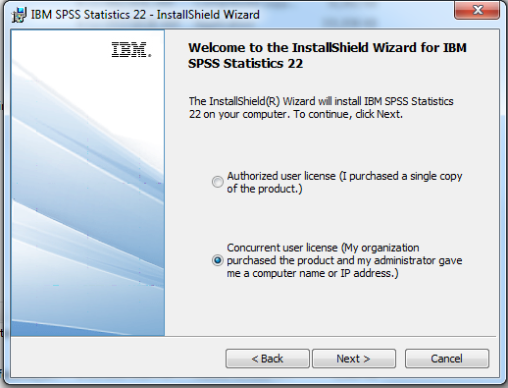
- Read and accept the term of the license agreement and click “Next”.
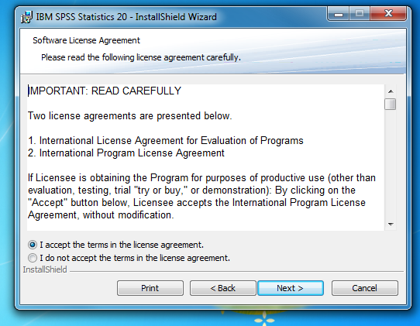
- Enter its-spss.its.fsu.edu into the “License Manager name or Server IP Address” line and click “Set”.
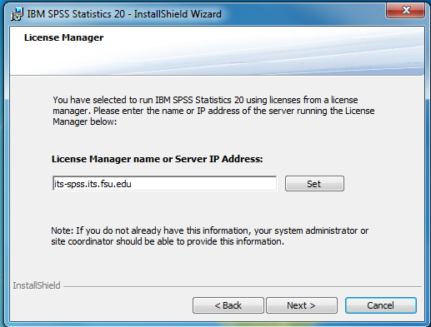
- Select the languages you wish to use on the screen and click “Next”.
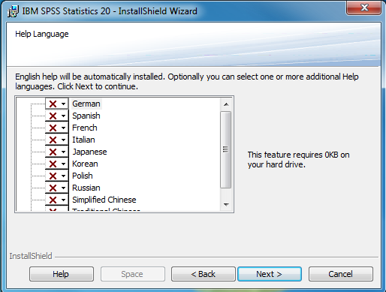
- Choose whether or not to enable JAWS (PC Only) and press “Next”.
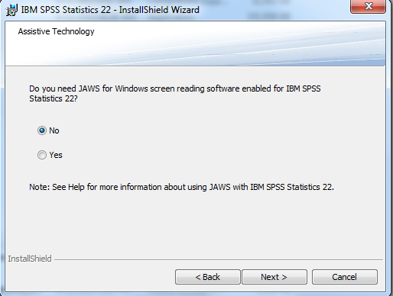
- Select whether or not to install SPSS – Essentials for Python
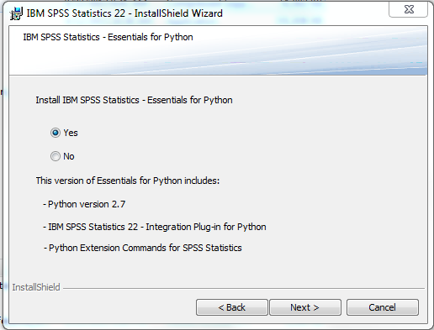
- Select the Destination Folder and click “Next”.
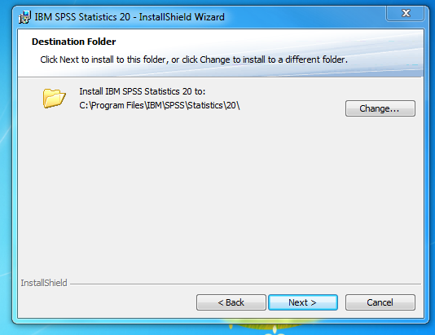
- Then click “Install”.
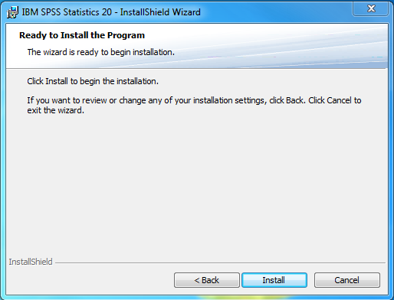

Changes on desktop PCs
Note: You must be an Administrator to make these changes.
- Open Windows Explorer and navigate to your SPSS installation directory. (Default: C:\Program Files\IBM\SPSS\Statistics\22\)
- Rename lservrc to lservrc.old
- Copy spssprod.inf to the desktop
- Open spssprod.inf with Notepad
- Edit the line starting with DaemonHost=no-net to DaemonHost=its-spss.its.fsu.edu
- Save spssprod.inf to the desktop
- Rename spssprod.inf in the SPSS installation folder to spssprodold.inf
- Move the spssprod.inf from the desktop to the SPSS installation folder
Changes to Macs and laptops
- You must uninstall and reinstall SPSS on Macs and laptops
- While reinstalling SPSS, chose the Network License option
- Enter its-spss.its.fsu.edu into the network address line

